**US05 – Confirmation both parties**

## **Short description**

**In order to** visualize the status of the (possible) confirmation

**As a** user

**I want to** add colors/warning messages

## **Detailed description**

The business rules for visualization can be summarized as follows:

* Months in the future/no action required yet:
  + Color: grey
  + no symbol
* One person has confirmed that he/she had a monthly conversation
  + Color: yellow
  + Symbol: hourglass (as in: waiting)
* Both have confirmed that a monthly conversation took place
  + Color: green
  + Symbol: check mark
* None have confirmed within the appropriate time range
  + Color: red
  + Symbol: ‘X’

## **Mockups**

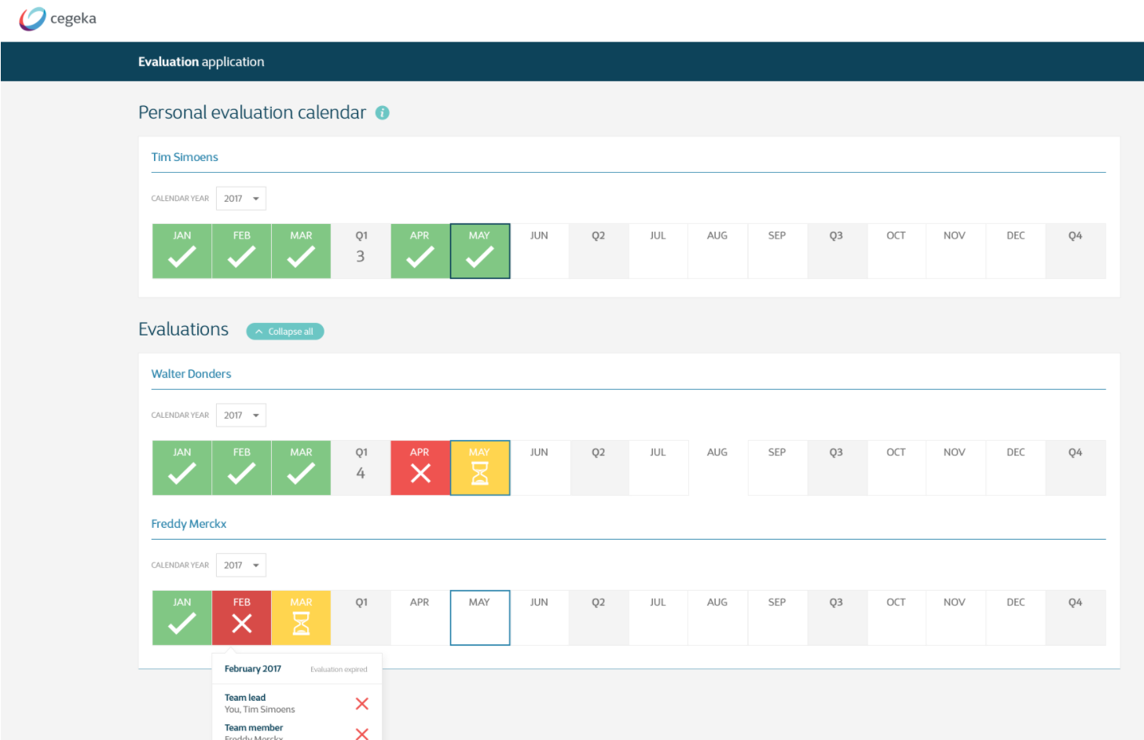

## **Technical description**

## **Acceptance criteria**

|  |  |  |
| --- | --- | --- |
| **Given** | **When** | **Then** |
| I am logged into the tool and have not yet added a confirmation for a certain month (still in time limits) | The person I should have the conversation with has not yet added a confirmation for the same month | The button is grey, and doesn’t display a symbol |
| I am logged into the tool and have not yet added a confirmation for a certain month (still in time limits) | The person I should have the conversation with has added a confirmation for the same month | The button is yellow, and displays three dots as a symbol (hourglass, representing waiting) |
| I am logged into the tool and have added a confirmation for a certain month (still in time limits) | The person I should have the conversation with has not yet added a confirmation for the same month | The button is yellow, and displays three dots as a symbol (hourglass, representing waiting) |
| I am logged into the tool and have added a confirmation for a certain month (still in time limits) | The person I should have the conversation with has added a confirmation for the same month | The button is green, and displays a check mark as a symbol |
| I am logged into the tool and have not yet added a confirmation for a certain month (no longer in time limits) | The person I should have the conversation with has not yet added a confirmation for the same month | The button is grey, and doesn’t display a symbol  The button is red, and displays a cross (X) as a symbol |